Template for MBR Research Question Review (RQR) Submission

Overview
An MBR RQR article is expected to:
- Identify a research question of practical importance to managers
- Present a summary of the results of a systematic search of the research literature related to the question; this will normally be done in tabular form
- List the key takeaways of the search
- Identify strengths and weaknesses of the literature in terms of addressing the question being asked
Such an article would normally be around 5 to 15 pages.
Acceptance of an MBR RQR submission will take into consideration:
- The significance of the question being asked
- The degree to which the results provide value to managers and researchers. It should be noted that such value might derive from two nearly opposite sources. Specifically:
  - Research findings are identified that could provide novel insights into business and managerial practices, introduce concepts likely to be broadly accessible to MBR readers, offer ideas that offer a pathway to best practices
  - Existing research appears to offer little of value in addressing the significant question, thereby presenting an opportunity to valuable future manager-researcher collaboration.
- Presentation of findings in a manner likely to engage readers.
- The degree to which it seems likely to contribute to business and managerial knowledge.

Instructions
- Save this document under the name to be used with the RQR submission
- Delete the “Instructions” page
- On the first page, replace the generic information with your specific information:
  - Leave the “Research Question Review” heading
  - Title: Use the Title style, centered.
  - (Author information will be submitted in the review system)
- Styles should be used for all headings
  - Main headings should use Heading 1 style
    - Sub headings should use Heading 2 style
      - Heading 3, Etc.
- Graphics should be embedded as .jpg, .gif or .png images. Do not use Office drawings.
- References should be listed at the end, in APA format
- Fill in the information specified in the Reviewer Appendix at the end of the template. This information will not be included in the published version of the article, but will be used during the review process.

  - Research Question Review Cover Page

The Research Question Goes Here

Tagline
In this section, place a 25-50 word paragraph that captures the importance of the research question. This will not appear in the article itself, but will be used in the contents. Since the question itself is the title, it should not be repeated in the tagline.

Keywords
Put 5-10 keywords that will be used to index the article and make it easier to find when a search is done.

Executive Summary
A 150-250 word summary that summarizes the importance of the research question and the results of the review. This will appear at the beginning of the article.

  - Research Question Review

The Research Question Goes Here

Introduction
An RQR article will normally begin with a brief description of the context of the RQR, hopefully half a page of less. It should introduce the topic focus of the RQR and how the RQR came about. This section should avoid being a repetition of the executive summary.

Protocol
A very brief summary of the protocol used to search the literature should be included here. It might include the databases searched, the number of articles downloaded and the number of articles summarized. A more extensive description of the protocol should be included in the reviewer appendix. This section should not be more than a paragraph.

Literature Summary
The preferred presentation of a literature summary is a table. There are a variety of possible formats that are possible. If a large number of articles have relevance to the question, with many reporting similar conclusions, then the following table format may be most appropriate:
Table 1: Findings-Multiple Sources Table Format
Finding | Sources
Statement of the specific finding from the literature in terms accessible to managers | Listing of sources, separated by semi-colons, in APA format (i.e., author(s), year).
Next finding… | Next set of sources

Where a smaller number of references is considered, and each reference has more significance, it might be more appropriate to use a table format such as the following:
Table 2: Individual Source-Multiple Findings Table
Source | Findings
Authors, (year) and title of the article | - Listing of the findings from the specific article.  - Use bullet point format where appropriate.
Next source… | - Next set of findings

The ordering of the tables should be given careful consideration. Where a conceptual organization can be used that helps clarify question, an additional column might be warranted. For example, the following table (Gill, 2006, p. 8) shows a summary that addresses the question “What is task complexity?” organized by classes, using the Findings-Multiple Sources (Table 1) format and adding a column to the left.
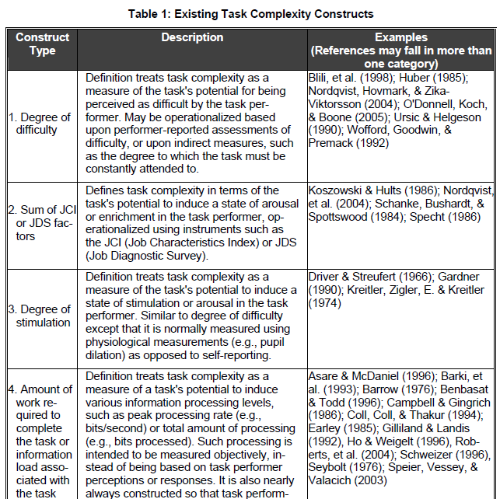
The next table (Gill, 2012) illustrates a modified version of the Single Source-Multiple Findings tables, where the source remains on the left and the title is omitted. In this table, research type is used as the organizing principle and the theme of the research and findings are separated. Both of these example tables would likely be considered too academic in their presentation for the MBR audience. Moreover, these second of these table surveys an area of research, rather than focusing on a specific research question of interest to practice, which is the preferred target of MBR RQR articles. For this reason, tables such as these would more likely be found in categories such as relevant theory articles, empirical findings articles and research case studies. Nevertheless, the formats can be adapted to RQR articles.
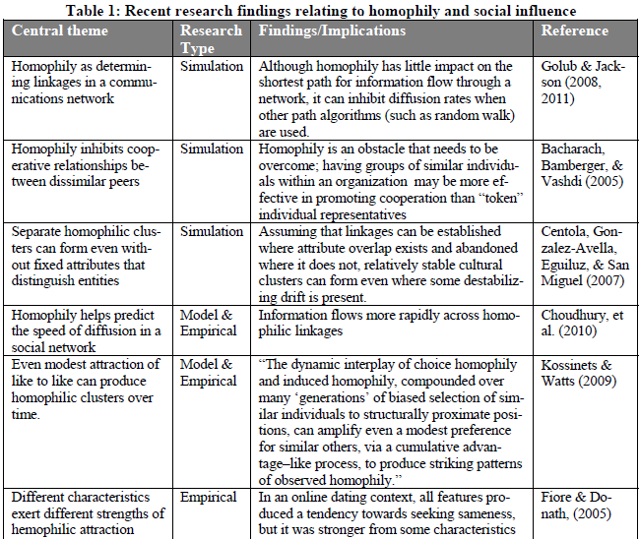

Discussion
In this section, the results of the RQR are synthesized by the author and, ideally, framed in terms of the broader academic research literature. Of particular interest are observations that findings from many sources seem to confirm each other and observations that they tend to conflict with each other or fail to replicate.
In some cases, the table of findings itself may provide sufficient value to justify publication. In other cases, the results may be so inadequate that there is little value in attempting to synthesize them. In these cases, to avoid repetition it may make sense to go directly to conclusions.

Conclusions
The summary of the key takeaways from the RQR. Normally, these should be under a page and should be sufficiently self-contained that a reader can jump to them and still understand them.

References
APA format should be used for all references, e.g.,

Gill, T.G. (2012). Informing on a rugged landscape: Homophily vs. expertise. Informing Science: the International Journal of an Emerging Transdiscipline, 15, 49-91. Retrieved from http://www.inform.nu/Articles/Vol15/ISJv15p049-091Gill616.pdf
Gill, T. G. and Hicks, R. (2006). Task complexity and informing science: A synthesis. Informing Science: the International Journal of an Emerging Transdiscipline, 9, 1-30. Retrieved from http://inform.nu/Articles/Vol9/v9p001-030Gill46.pdf

Reviewer Appendix

The reviewer appendix is not published with the article, but it is a critical component of the review process. It is required to allow the manuscript’s reviewers to assess whether the RQR was conducted according to standards of rigor consistent with publishable research. The author(s) should fill out each of sections that follows.

The RQR Question
Explain the process through which RQR question was selected. If the topic of the RQR was motivated by a business question or a research interest, describe the research conducted by the author(s) prior to formulating the question.

The RQR Protocol
Describe the process through which the literature review for the RQR was conducted. Include information on:
- General databases searched (for business-related questions, these will normally be ABI-Inform and Google Scholar). For each database, indicate:
  - Specific queries tried—authors will do themselves a favor if they keep a record of this as the search progresses
  - Types of results from each query
- Specific databases searched (IT-related questions, for example, these might include the library’s Gartner database). For each database, indicate:
  - Why it was selected? (Advice of a reference librarian would be a good example of a reasonable justification if a more obvious justification is not available)
  - Specific queries tried—authors will do themselves a favor if they keep a record of this as the search progresses
  - Types of results from each query
- What was the process through which articles for review were chosen?
- What was the process through which a summary on each article was prepared?

The Discussion and Conclusions
Describe the process through which the discussion and conclusions were developed. If further synthesis of the findings in the results table was not attempted, explain the basis for this decision.

Permissions
The author(s) of a manuscript is responsible for acquiring necessary permissions prior to publication. For interviews, these permissions are likely to involve permission to use any external materials (such as graphics or extensive quoted content) that are included in the discussion.
Particular care should be taken when copying images. Even when it is claimed that they are available to copy, it is not always the case that the site displaying them has the right to make that claim. When copying a graphic, if there is any doubt you can recreate the graphic (using your own styling) in PowerPoint or some other tool, then cite the source as “Adapted from {source citations}”.

